**Konichiwa from Japan!**



**June 2014**

**Newsletter 2**

"I can't believe it's June already!" seems to be what most people are saying, and I've been living in Japan for four months. I am extremely thankful to those who have thought of me and prayed for me. Your prayers have not gone unanswered!

Teaching English to children and adults is progressing well. Slowly but surely, my relationship with my students is growing. My adult students have felt that they can open up a little more about their personal lives and my younger students wait eagerly for their weekly hug after class. It is incredible how quickly children are willing to give and receive love! As adults, we are often less willing to trust others and give unconditionally without the expectation of receiving love in return. Although my Japanese language skills are very limited, I can still communicate the love of Jesus with a hug and a warm smile. One of my favourite classes to teach at the moment is at Ishibashi Christ Church. The class is made up of four little boys, between the ages of 3 and 5, and their mothers. Their mothers are there to encourage them in speaking English and to help them to complete tasks. It’s so adorable to watch the mothers doing the actions to the English songs along with their sons. Some of my favourite moments occur when I am simply interacting with the children and sharing my heart. I can see that it makes a big difference to them that their Christian English teacher really cares for them.

Some Japanese adults develop an appreciation for their English teachers in a short space of time and they show their generosity by giving gifts. Whenever I am given a gift, I write a letter of thanks to the giver. Recently, I have realised that this is a perfect opportunity to encourage the student with a Bible verse or Bible tract. Some students are so surprised to receive a handwritten letter that their face literally lights up and they beam with a smile that stretches from ear to ear. It is incredible how something so small can bring so much joy.

Spring has sprung in Japan and the flowers are blooming and the birds are building their nests and tending to their chicks. Near Ikoma station is a mini mall with mostly restaurants on either side of a wide corridor. In the last month or so, countless Barn swallows have built their nests there and warmed their eggs until their chicks hatched. It is an amazing sight to see!

Every time I walk to the station, the sight of the little chicks chirping and calling to their parents makes me feel in awe of our Father's phenomenal creation. Each nest has four to six small chicks and the parents are fiercely dedicated to meeting their offspring's every need. At night the chicks sleep comfortably in a warm nest while their parents sacrifice their own comfort, sleeping on the cold metal beside them. If anything disturbs the chicks, their parents are quick to swoop in and protect them. This also reminds me that our Father has said in Exodus 19:4, “You yourselves have seen what I did to Egypt, and how I carried you on eagles’ wings and brought you to myself.” And what Jesus said in Matthew 10:29-31, “Are not two sparrows sold for a penny? Yet not one of them will fall to the ground outside your Father’s care. And even the very hairs of your head are all numbered. So don’t be afraid; you are worth more than many sparrows.”

May Jesus continue to bless you with His presence and grace,

Marie

marie2k23@hotmail.com

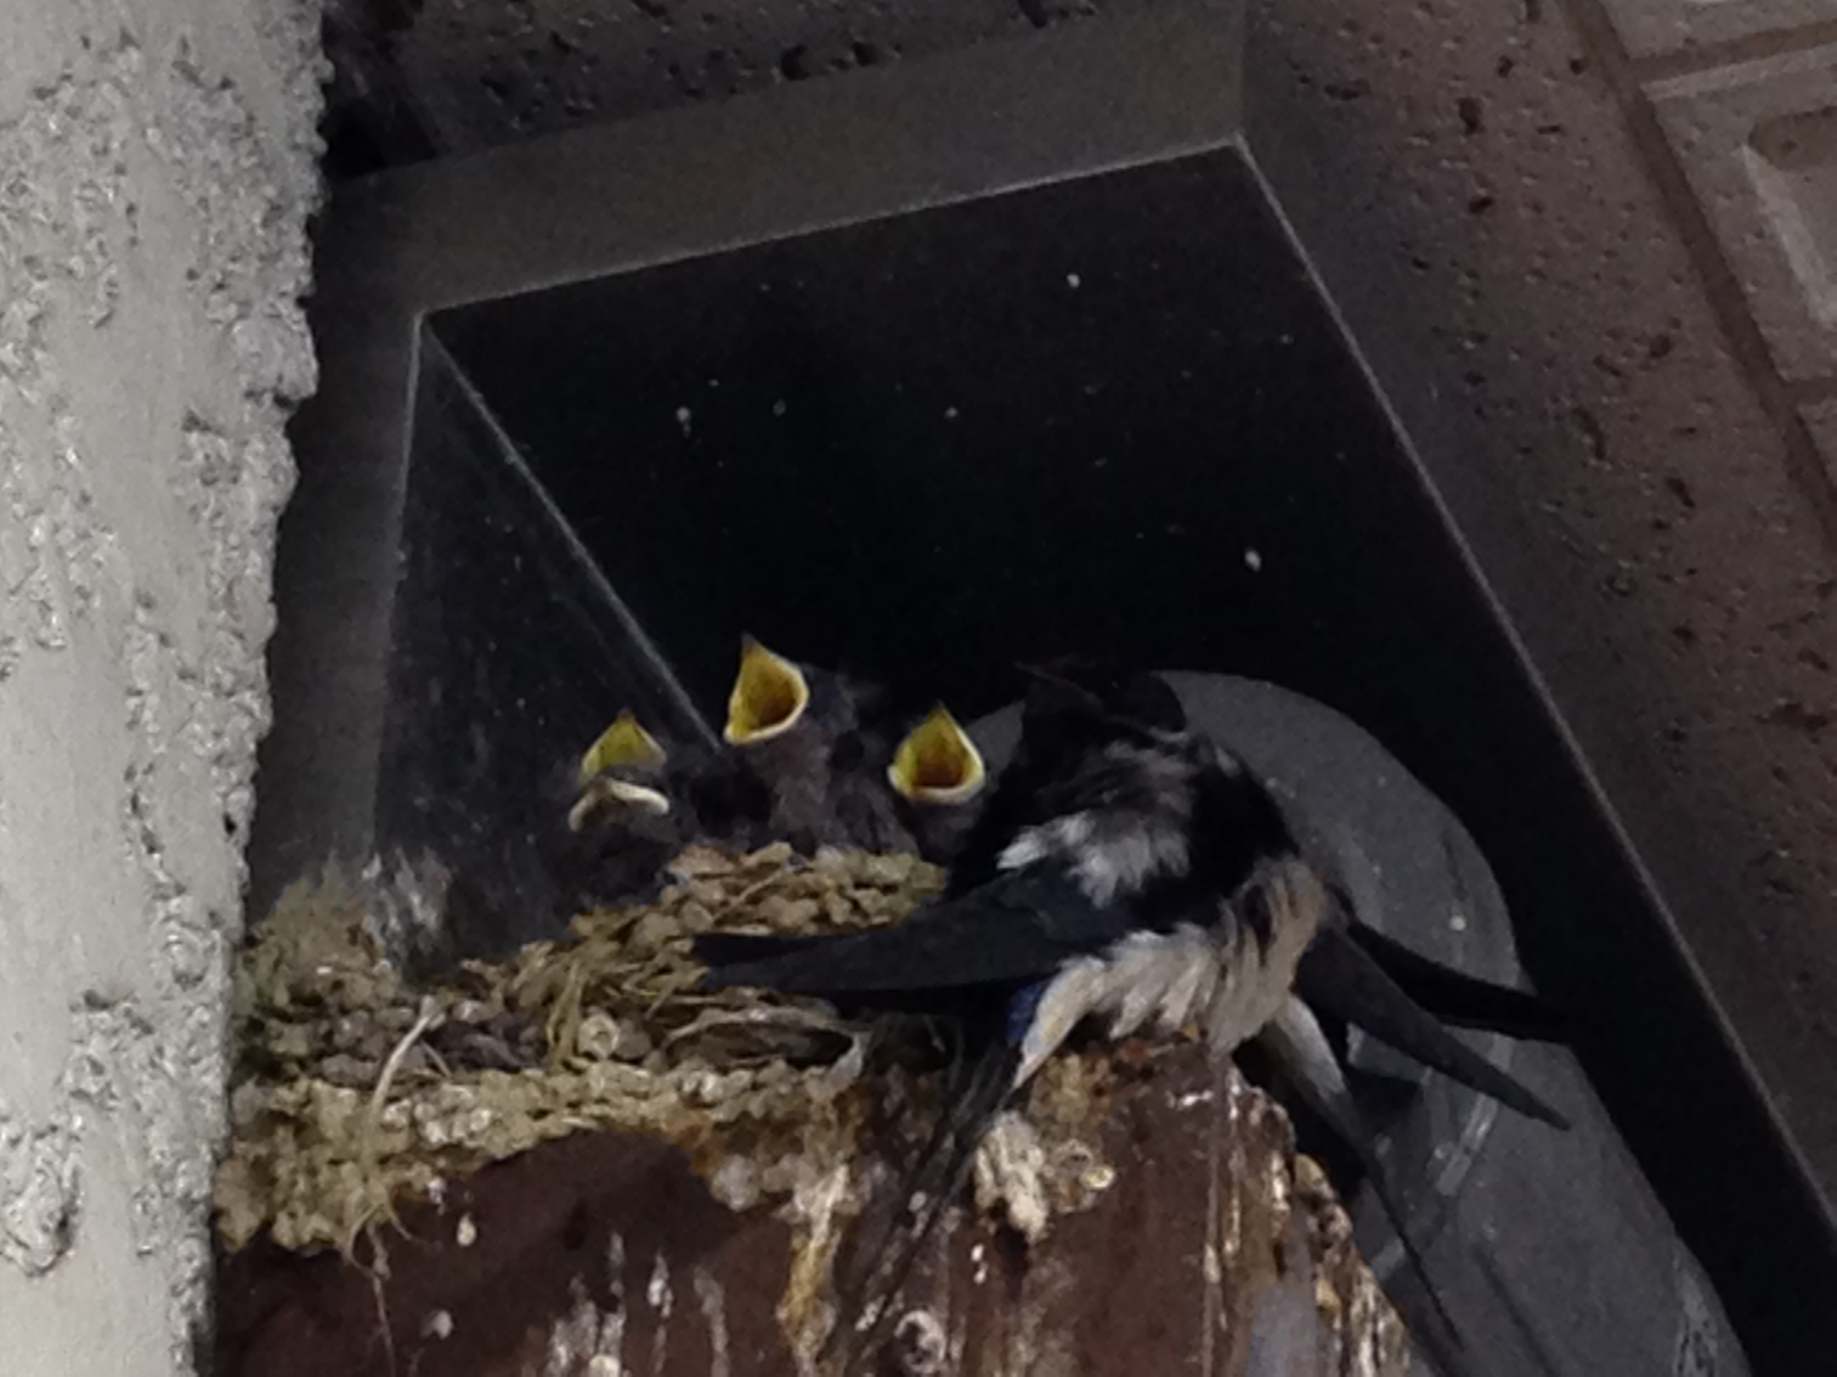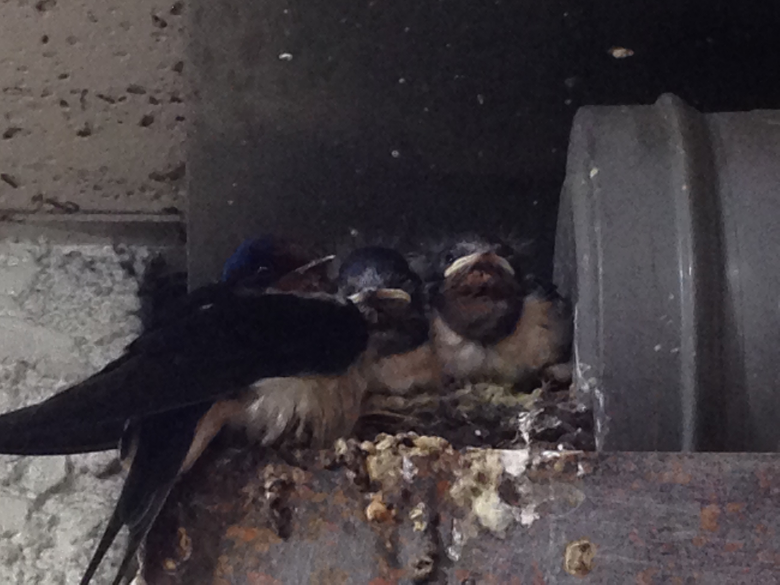

If you would like to receive newsletters from Japan Mission, in Afrikaans, by email or snail mail, please send me your email address or street address.

Japan Mission, 7-40 Monzen Cho, Ikoma, Nara, 630-0266, JAPAN.

Tel: +81-743-73-1754

www.japanmission.org

If you would like to support the work of Japan Mission the banking details are as follows:

Standard Bank, Account no. 010 333 126, Branch no. 014845

ABSA Bank, Account no. 090 161 334, Branch no. 334-645